ASSIGNMENT-2.5
2303A52332
Task 1: Refactoring Odd/Even Logic (List Version)
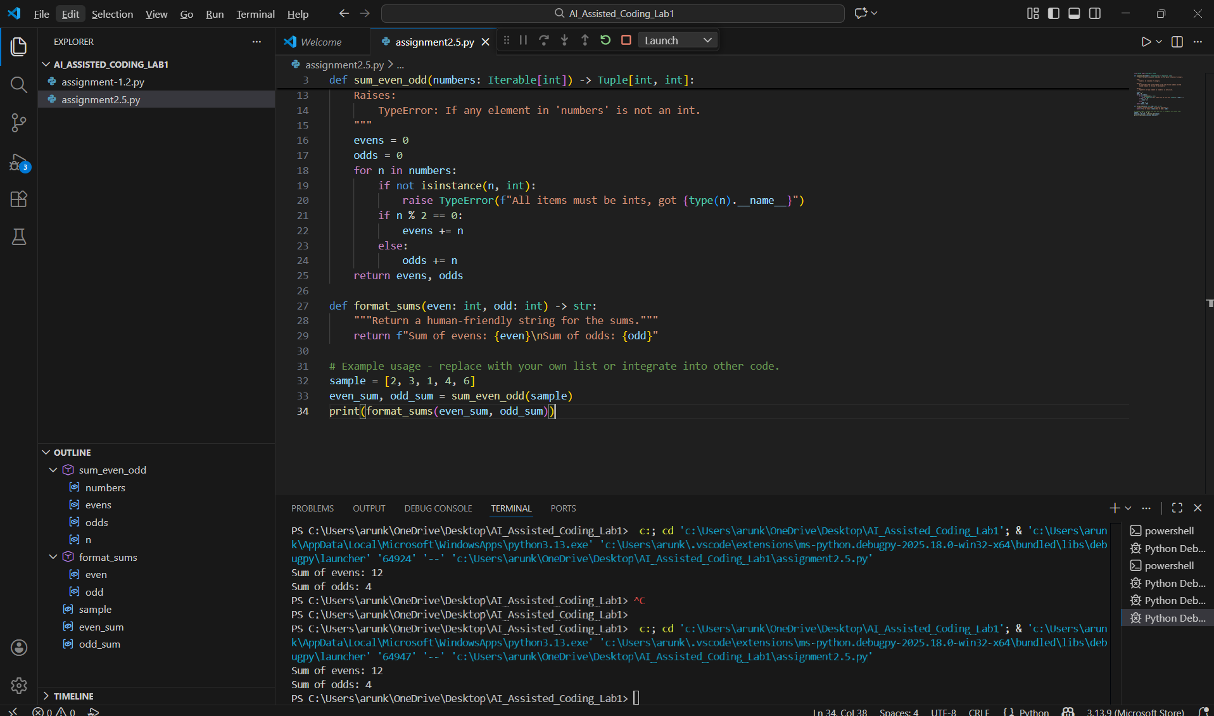

Task 2: Area Calculation Explanation
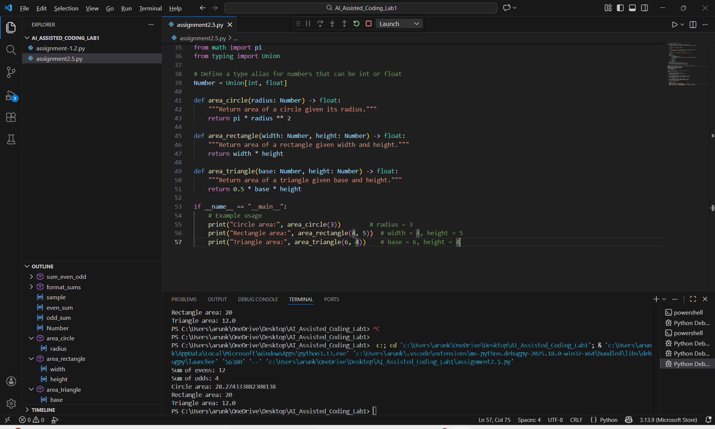
Task 3: Prompt Sensitivity Experiment
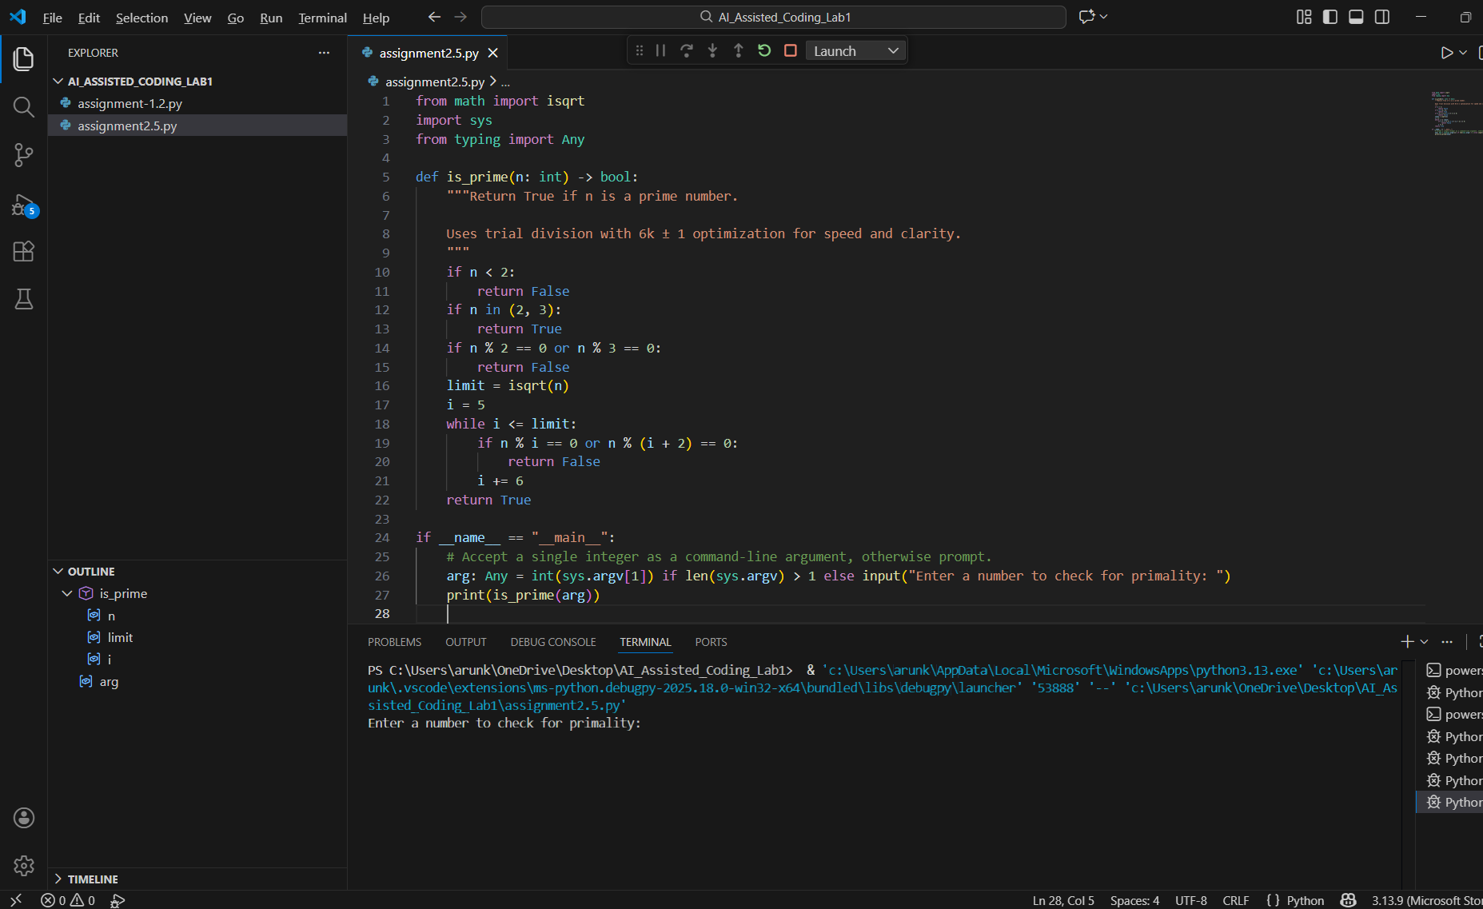
Optimized:
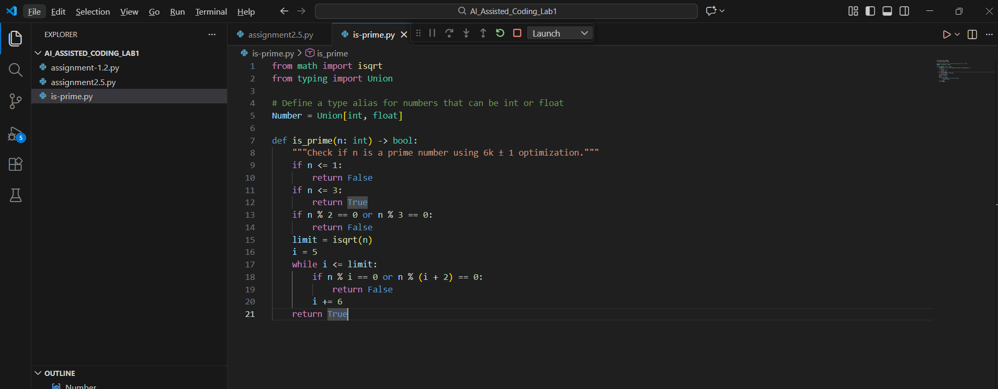

Task 4: Tool Comparison Reflection
Task
Evaluate GitHub Copilot in terms of usability and code quality, based on your experience during this lab.
Reflection
GitHub Copilot is an effective AI-assisted coding tool that integrates directly into the development environment such as Visual Studio Code. It provides real-time code suggestions while typing, which significantly improves coding speed and reduces syntax errors.
Copilot performs well in generating:
- Loops and conditional logic
- Functions and reusable code
- Optimized versions of existing programs
The quality of code generated by GitHub Copilot depends on the clarity of comments and prompts written by the developer. Clear and descriptive prompts result in better, optimized, and readable code.
Unlike chat-based AI tools, GitHub Copilot focuses more on continuous coding assistance rather than long explanations, making it suitable for regular programming tasks and professional development.

Final Recommendation
GitHub Copilot is recommended for students and developers who want:
- Faster coding
- IDE-based AI support
- Clean and optimized code generation

